**Practice project**

Implement Spring Security with Authentication

Output:

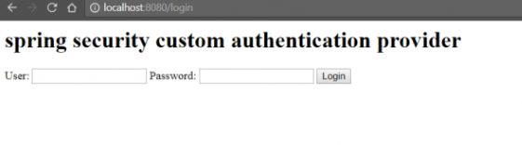

After enter correct username & password

